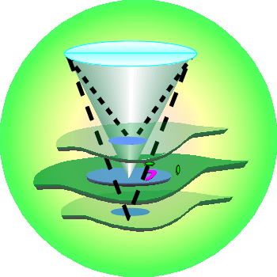
BIOL5070 Spring Semester
3 Credits MW-PLSB03 0

Practical Aspects of Light Microscopy
in the Biological Sciences
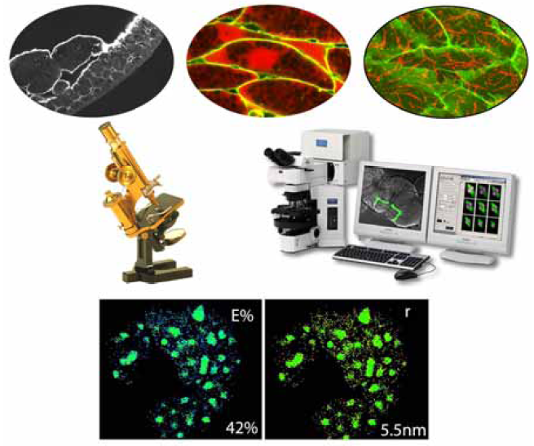
This is a hand on training course on various microscopy techniques (theory & laboratory) including Phase contrast, DIC, wide-field, confocal, Multiphoton, resonance energy transfer (FRET), fluorescence lifetime imaging (FLIM), spectral imaging, total internal reflection microscopy (TIRF), Super resolution microscopy, etc. Biological applications are discussed for each microscopy techniques. The grading is by participation in the class, assignments, presentations, multiple choice questions test, and one-on-one discussion and training. No final test, but the student has to complete a project based on a microscopic techniques and poster presentation. (Note: The one-on-one discussion with the instructor and alignment of the basic microscopy system is not included in the regular class schedule and this will take may be about 3-4 hrs extra time).

Prerequisite: Instructor Permission (4th year Undergraduate Students and Graduate Students)
Instructor: Prof. Ammasi Periasamy
Email: ap3t@virginia.edu
Sign Up: Login to the SIS and Search for BIOL5070

